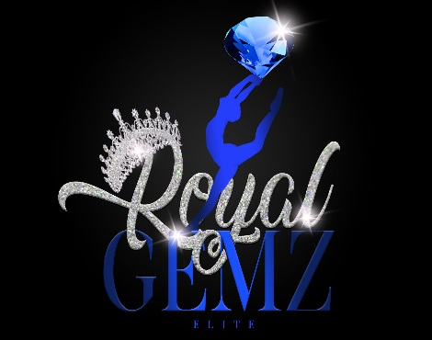
Release and Waiver of Liability
All parents and guardians must read and sign below.

I understand that my child’s participation on Royal Gemz Elite, LLC majorette dance team is entirely voluntary. I understand events may involve physical exertions- such as bending, lifting, and etc. and despite precautions, accidents and injuries can occur. I agree to release Royal Gemz Elite, LLC including staff members, dancers, choreographers, and facilities used by both entities from any cause of action, claims, or demands now and in the future. I agree to assume all risk and expenses that occur due to my child’s involvement in participating on the team.

I __________________________, agree that in the event that I observe any unsafe conduct or conditions before, during, or after practice, performances, or competitions, to report my observations to the Owner, or any staff member as soon as possible. I understand that it is my responsible to make Royal Gemz Elite, LLC staff aware of any known physical or medical conditions prior to my child’s participation.

By signing below, I agree that I have read and understood the above release and waiver of liability and fully understand its contents. I voluntarily agree to the terms and conditions above.

Parent/Guardian Name: (Please Print) ______________________ Date: _______

Child’s Name: ______________________________ Child’s Date of Birth: __________

Parent or Guardians Signature: _____________________ Phone:___________________

